


Select prepare and serve various cheeses
D1.HCC.CL2.21
Trainee Manual






Select prepare and serve various cheeses

D1.HCC.CL2.21

Trainee Manual




Project Base
William Angliss Institute of TAFE
555 La Trobe Street
Melbourne 3000 Victoria
Telephone: | (03) 9606 2111
Facsimile: | (03) 9670 1330
Acknowledgements
Project Director: | Wayne Crosbie
Chief Writer: | Alan Hickman
Subject Writer: | Garry Blackburn
Project Manager: | Alan Maguire
Editor: | Jim Irwin
DTP/Production: | Daniel Chee, Mai Vu, Jirayu Thangcharoensamut, Kaly Quach

The Association of Southeast Asian Nations (ASEAN) was established on 8 August 1967. The Member States of the Association are Brunei Darussalam, Cambodia, Indonesia, Lao PDR, Malaysia, Myanmar, Philippines, Singapore, Thailand and Viet Nam.
The ASEAN Secretariat is based in Jakarta, Indonesia.
General Information on ASEAN appears online at the ASEAN Website: www.asean.org.
All text is produced by William Angliss Institute of TAFE for the ASEAN Project on “Toolbox Development for Front Office, Food and Beverage Services and Food Production Divisions”.
This publication is supported by the Australian Government’s aid program through the ASEAN-Australia Development Cooperation Program Phase II (AADCP II).
Copyright: Association of Southeast Asian Nations (ASEAN) 2013.
All rights reserved.
Disclaimer
Every effort has been made to ensure that this publication is free from errors or omissions. However, you should conduct your own enquiries and seek professional advice before relying on any fact, statement or matter contained in this book. The ASEAN Secretariat and William Angliss Institute of TAFE are not responsible for any injury, loss or damage as a result of material included or omitted from this course. Information in this module is current at the time of publication. Time of publication is indicated in the date stamp at the bottom of each page.
Some images appearing in this resource have been purchased from stock photography suppliers Shutterstock and iStockphoto and other third party copyright owners and as such are non-transferable and non-exclusive. Clip arts, font images and illustrations used are from the Microsoft Office Clip Art and Media Library. Some images have been provided by and are the property of William Angliss Institute.
Additional images have been sourced from Flickr and SKC and are used under Creative Commons licence: http://creativecommons.org/licenses/by/2.0/deed.en
File name: TM_Select_prepare_&_serve_various_cheeses_FN_020214





Table of contents
Introduction to trainee manual 1
Unit descriptor 3
Assessment matrix 5
Glossary 7
Introduction 9
Element 1: Select supplier to purchase cheese and equipment 11
Element 2: Prepare cheese for service 17
Element 3: Present cheese 23
Element 4: Store cheese 27
Presentation of written work 35
Recommended reading 37
Trainee evaluation sheet 39
Trainee Self-Assessment Checklist 41

Introduction to trainee manual

To the Trainee
Congratulations on joining this course. This Trainee Manual is one part of a ‘toolbox’ which is a resource provided to trainees, trainers and assessors to help you become competent in various areas of your work.
The ‘toolbox’ consists of three elements:
- A Trainee Manual for you to read and study at home or in class
- A Trainer Guide with Power Point slides to help your Trainer explain the content of the training material and provide class activities to help with practice
- An Assessment Manual which provides your Assessor with oral and written questions and other assessment tasks to establish whether or not you have achieved competency.
The first thing you may notice is that this training program and the information you find in the Trainee Manual seems different to the textbooks you have used previously. This is because the method of instruction and examination is different. The method used is called Competency based training (CBT) and Competency based assessment (CBA). CBT and CBA is the training and assessment system chosen by ASEAN (Association of South-East Asian Nations) to train people to work in the tourism and hospitality industry throughout all the ASEAN member states.
What is the CBT and CBA system and why has it been adopted by ASEAN?
CBT is a way of training that concentrates on what a worker can do or is required to do at work. The aim is of the training is to enable trainees to perform tasks and duties at a standard expected by employers. CBT seeks to develop the skills, knowledge and attitudes (or recognise the ones the trainee already possesses) to achieve the required competency standard. ASEAN has adopted the CBT/CBA training system as it is able to produce the type of worker that industry is looking for and this therefore increases trainees chances of obtaining employment.
CBA involves collecting evidence and making a judgement of the extent to which a worker can perform his/her duties at the required competency standard. Where a trainee can already demonstrate a degree of competency, either due to prior training or work experience, a process of ‘Recognition of Prior Learning’ (RPL) is available to trainees to recognise this. Please speak to your trainer about RPL if you think this applies to you.
What is a competency standard?
Competency standards are descriptions of the skills and knowledge required to perform a task or activity at the level of a required standard.
242 competency standards for the tourism and hospitality industries throughout the ASEAN region have been developed to cover all the knowledge, skills and attitudes required to work in the following occupational areas:
- Housekeeping
- Food Production
- Food and Beverage Service
- Front Office
- Travel Agencies
- Tour Operations.
All of these competency standards are available for you to look at. In fact you will find a summary of each one at the beginning of each Trainee Manual under the heading ‘Unit Descriptor’. The unit descriptor describes the content of the unit you will be studying in the Trainee Manual and provides a table of contents which are divided up into ‘Elements’ and ‘Performance Criteria”. An element is a description of one aspect of what has to be achieved in the workplace. The ‘Performance Criteria’ below each element details the level of performance that needs to be demonstrated to be declared competent.
There are other components of the competency standard:
- Unit Title: statement about what is to be done in the workplace
- Unit Number: unique number identifying the particular competency
- Nominal hours: number of classroom or practical hours usually needed to complete the competency. We call them ‘nominal’ hours because they can vary e.g. sometimes it will take an individual less time to complete a unit of competency because he/she has prior knowledge or work experience in that area.
The final heading you will see before you start reading the Trainee Manual is the ‘Assessment Matrix’. Competency based assessment requires trainees to be assessed in at least 2 – 3 different ways, one of which must be practical. This section outlines three ways assessment can be carried out and includes work projects, written questions and oral questions. The matrix is designed to show you which performance criteria will be assessed and how they will be assessed. Your trainer and/or assessor may also use other assessment methods including ‘Observation Checklist’ and ‘Third Party Statement’. An observation checklist is a way of recording how you perform at work and a third party statement is a statement by a supervisor or employer about the degree of competence they believe you have achieved. This can be based on observing your workplace performance, inspecting your work or gaining feedback from fellow workers.
Your trainer and/or assessor may use other methods to assess you such as:
- Journals
- Oral presentations
- Role plays
- Log books
- Group projects
- Practical demonstrations.
Remember your trainer is there to help you succeed and become competent. Please feel free to ask him or her for more explanation of what you have just read and of what is expected from you and best wishes for your future studies and future career in tourism and hospitality.

Unit descriptor
Select prepare and serve various cheeses
This unit deals with the skills and knowledge required to Select prepare and serve various cheeses in a range of settings within the hotel and travel industries workplace context.
Unit Code:
D1.HCC.CL2.21
Nominal Hours:
10 hours

Element 1: Select supplier to purchase cheese and equipment
Performance Criteria
1.1 Identify and select suppliers for purchasing of products
1.2 Identify cheese varieties required by the enterprise

Element 2: Prepare cheese for service
Performance Criteria
2.1 Bring product to appropriate serving temperature
2.2 Use correct preparation equipment safely
2.3 Prepare required garnishes and accompaniments to complement service style

Element 3: Present cheese
Performance Criteria
3.1 Present cheese to enterprise standards
3.2 Decorate cheese with complementary garnishes and accompaniments

Element 4: Store cheese
Performance Criteria
4.1 Minimise wastage through correct purchasing practices
4.2 Minimise wastage through correct storage practices
4.3 Apply appropriate hygiene standards in the storage and handling of cheese
4.4 Access and use cheese leftovers appropriately

Assessment matrix
Showing mapping of Performance Criteria against Work Projects, Written Questions and Oral Questions
The Assessment Matrix indicates three of the most common assessment activities your Assessor may use to assess your understanding of the content of this manual and your performance – Work Projects, Written Questions and Oral Questions. It also indicates where you can find the subject content related to these assessment activities in the Trainee Manual (i.e. under which element or performance criteria). As explained in the Introduction, however, the assessors are free to choose which assessment activities are most suitable to best capture evidence of competency as they deem appropriate for individual students.
 |  |  | Work Projects | Written Questions | Oral Questions
Element 1: Select supplier to purchase cheese and equipment
1.1 | Identify and select suppliers for purchasing of products |  | 1.1 | 1, 2 | 1
1.2 | Identify cheese varieties required by the enterprise |  | 1.2 | 3, 4 | 2
Element 2: Prepare cheese for service
2.1 |  | Bring product to appropriate serving temperature | 21. | 5, 6 | 3
2.2 |  | Use correct preparation equipment safely | 2.2 | 7, 8 | 4
2.3 |  | Prepare required garnishes and accompaniments to complement service style | 2.3, 2.4 | 9 | 5
Element 3: Present cheese
3.1 | Present cheese to enterprise standards |  | 31. | 10 | 6
3.2 | Decorate cheese with complementary garnishes and accompaniments |  | 3.1 | 11 | 7
Element 4: Store cheese
4.1 |  | Minimise wastage through correct purchasing practices | 4.1 | 12 | 8
4.2 |  | Minimise wastage through correct storage practices | 4.2 | 13 | 8
4.3 |  | Apply appropriate hygiene standards in the storage and handling of cheese | 4.3 | 14 | 10
4.4 |  | Access and use cheese leftovers appropriately | 4.4 | 15 | 11

Glossary
Term | Explanation
Blue Vein | Name give to style of cheese that has veins of blue mould throughout centre of cheese.
Brie | Soft French cheese with edible white mould made from cows milk made by Briand farmers(area of France)
Camembert | Similar to brie, also made with cows milk,
Cheddar | English Style cheese, cooked. Varies from soft crumbly texture to hard firm strong flavour. Versatile cheese made across the world. Many variations. Made from cows milk.
Cherve | Soft cheese, fresh made from goat or sheep’s milk.
Cloth bound | Cheese that has wrapped in muslin cloth to age, Supports edges so cheese stays together and cloth allow cheese to breath. Normally cheddar cheese is cloth bound.
Cottage cheese | Lumpy curd style cheese often containing cream.
Cream Cheese | American style unripened cheese.
Curd Cheese | General name given to all unripened cheese made from the separated curds of sheep and goats milk.
Feta | Greek cheese, white and crumbly texture made from goat or sheeps milk. Normally stored in a whey or brine and is cut square shape.
Gorgonzola | Italian Blue cheese, premier of this style from Italy. Penicullium gorgonzola is added to the curds with starter then packed into moulds and it is salted, pricked with needles and allowed to mature for 3 months while veining develops.
Labneh | Similar to quark, made from cultured milk product like yoghurt, strained of its whey, strong sharp taste.
Melting Quality | How well the cheese melts into fondues and sauces.
Mozzarella | Italian stretched curd cheese, soft in texture, white colour, originally made from buffalo milk but now made from cow’s milk.
Parmesan | Hard cheese from Italy. Parmigiano Reggiano being the King of Parmesan style. Can be up to 4 years old.
Pecorino | Hard cheese from southern Italy. Made from sheep’s milk. Not as crumbly as parmesan used both as grating cheese and table cheese.
Quark | Cottage style cheese that is usually sharper in flavour.
Ricotta | Fresh unripened Italian style cheese made from the whey of cow’s milk.
Roquefort | King of Blue Cheese, from the Massif Centrale in France, made from sheeps milk. Like gogonzola it is made and packed into moulds, pricked and left in caves for air to circulate. Caves have penicillium glaucum on the walls and the air transfers this to the cheese.
Stilton | English Blue produced from the 18th century. Sold in tall cylinder to distinguish from other blues.
Tilsit | Semi hard cheese strongly flavoured normally washed rind.
Washed rind | Cheese that have been washed in brine and will develop a sticky orange colour surface, can be washed in red wine for a darker colour.
Whey | Residual liquid from cheese making process.

Introduction
The original reason for cheese being made is simply a way to preserve milk.
Traditionally, there was an over-supply of milk during summer and spring and no milk at other times and to extend the shelf life of milk preservation was invented.
Cheese is a dairy product and is made from milk cream, skim milk or a mixture of any of these products.
Milk from many different animals can be used. For example cow, goat, sheep and buffalo milk all make excellent cheeses and soy milk is used as an alternative.
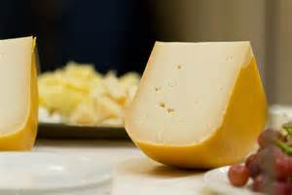
Cheese has four main ingredients:
- Milk
- Salt
- Rennet
- Cultures.
Due to different variations of the four basic ingredients, the different styles of production and the length of time taken to mature, a large range of cheeses are available.
Nutritionally cheese is a good source of calcium, protein and the B vitamin riboflavin. It also supplies phosphorus and a range of other minerals and vitamins.
The fat content of cheese varies from almost none in skim milk cheeses to around 35 % in hard cheeses.
Basically cheese is made by setting the milk with rennet which makes curds and whey.
The curd is cut to release moisture, the smaller the size the curd is cut the harder the style cheese.
The liquid is drained off and is referred to as whey. The thick curd undergoes further processing to produce different cheeses.
Cheeses are produced in countries with colder climates.
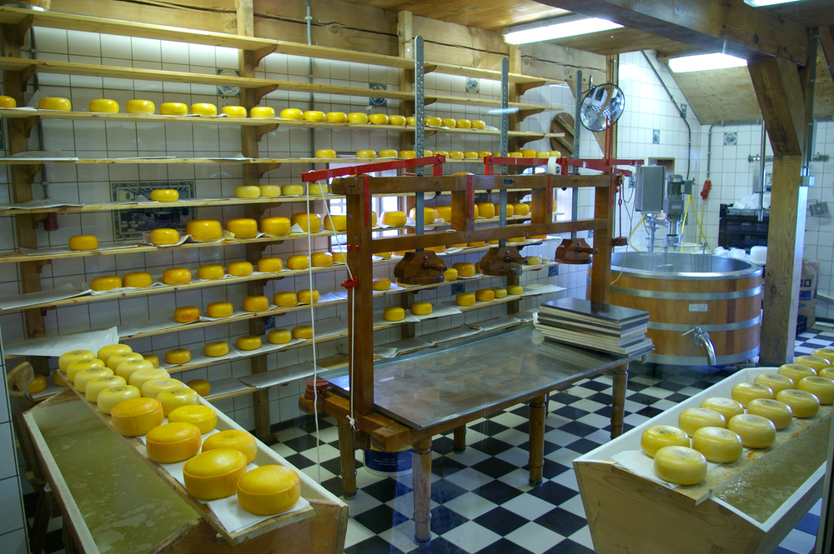

Types of Cheeses
There are three main types of cheeses:

Farmhouse
Farmhouse cheese is defined as cheese made on the farm, with milk from that farm.
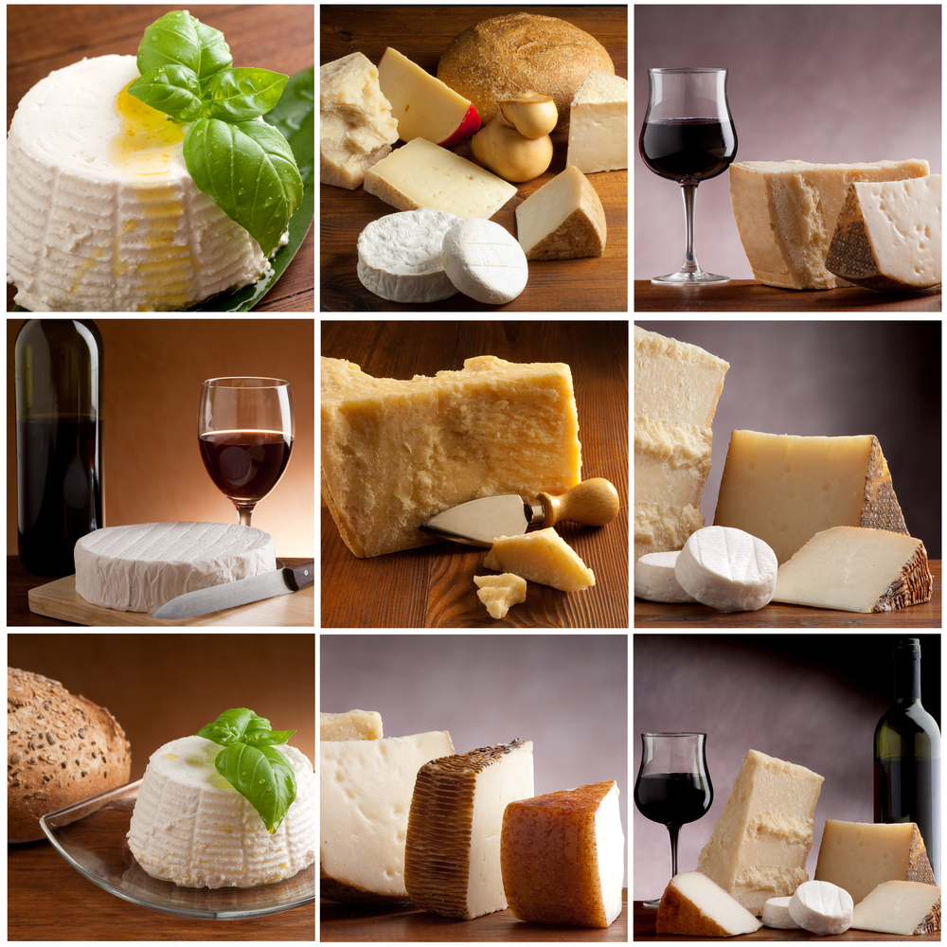
The cheese reflects the particular local character of the farm.
Factors that will influence the character of a farmhouse cheese are:
- The type of animal
- The soil
- The pasture
- The climate
- The skill of the farmer
- The skill of the cheese maker.
Generally speaking farmhouse cheeses are handmade, on a small scale, in limited quantities and command a premium price.

Specialist
Specialty cheeses are handmade by traditional artisan techniques using milk from a small number of farms based in a specific region.
The milk is sourced from a number of farms; therefore a wider selection of milk is available throughout the year.

Mass Produced (commodity)
Cheese produced on a large scale with consistency and quantity being the main aim in production. The result is to produce an affordable consistent product for the mass market
These tend to be budget priced and sold through supermarket type outlets.

Element 1:
Select supplier to purchase cheese and equipment

1.1 Identify and select suppliers for purchasing of products

Introduction
Finding a supplier is determined by several factors:
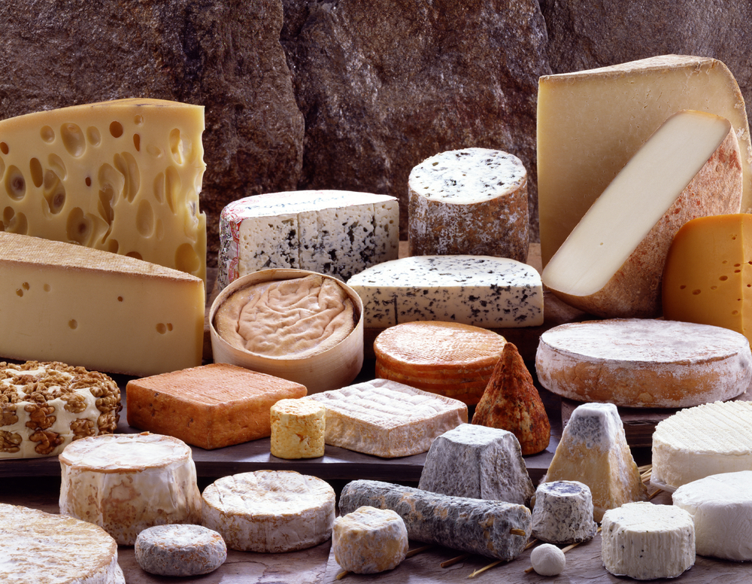
- What is the quality of cheese required by the establishment requirements?
- The range of products that the supplier has to offer?
- How regular the supply is available?
- How often the supplier can deliver to the establishment?
- The cost of the product from the supplier to the establishment.

Quality of supplier
Food Safety Plans require businesses to purchase from reputable suppliers.
A reputable supplier is one that is registered by the local authorities to operate as a food supply or food manufacturing business.
This means that that supplier is working to their own Food Safety Plan and is handling the food as it should be handled:
- Who the supplier purchases the supplies from is also a registered business
- The condition that food is stored while in the care of the supplier complies with the local Food Safety Standards
- How food is transported to other enterprises also complies with Food Safety requirements.

Food Safety Website across Asian region
http://www.foodhygieneasia.com
Thailand based website that explains HACCP based food safety
http://www.health.vic.gov.au/foodsafety/
Singapore Food Safety website
Students will need to become knowledgeable of the food safety requirements of the local government authorities.

1.2 Identify cheese varieties required by the enterprise

The major cheese categories include:

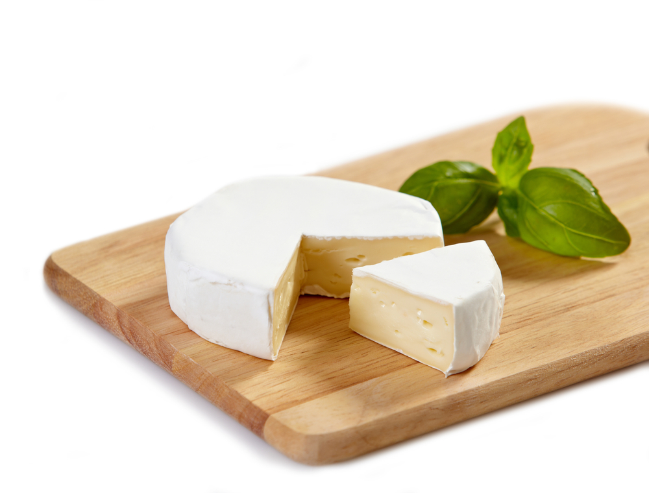

Fresh Cheese
Fresh cheese is unripened and acid set, sometimes with a little rennet. They are noted for their high moisture content and delicate flavour.
- Cherve – made from goats milk
- Ricotta – made from cow’s milk or can be goat’s milk from more artisan producers.

White Mould
White mould cheese is surface ripened using white penicillin mould which changes the curd and flavour.
- Brie
- Camembert.

Blue Mould
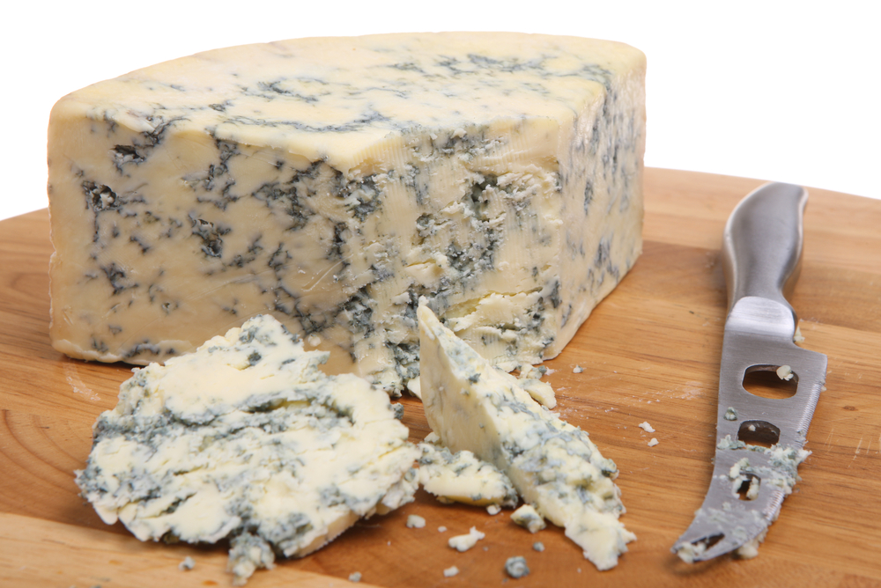
Blue moulds have veins of blue mould produced by piercing with stainless steel rods to allow air into the cheese.
These rods will have inoculate on them and this is to stimulate the growth of mould.
The famous French blue ‘Roquefort’ is stored in caves where the mould from the cave walls infect the cheese to give it unique flavour:
- Stilton – English
- Blue Brie – an extension of French style brie
- Gorgonzola – Italian blue cheese
- Roquefort the Classic French Blue – made from unpasteurised milk.

Semi Hard (round eye)
Are characterised by eyes or holes in the cheese.
These are formed by the expansion of gases during the ripening of the cheese.
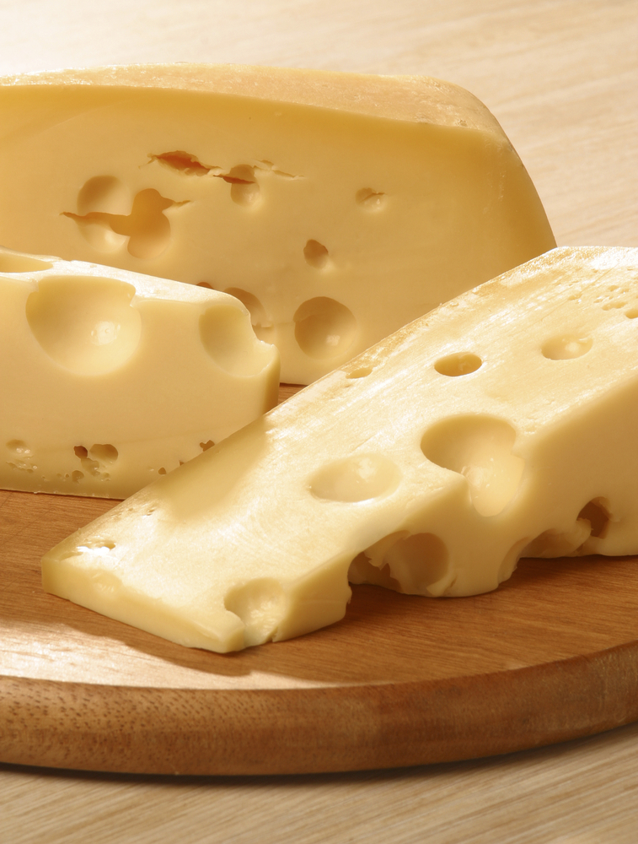

Swiss Style Cheese
- Ementhal
- Gruyere
- Tilsit
- Raclette.
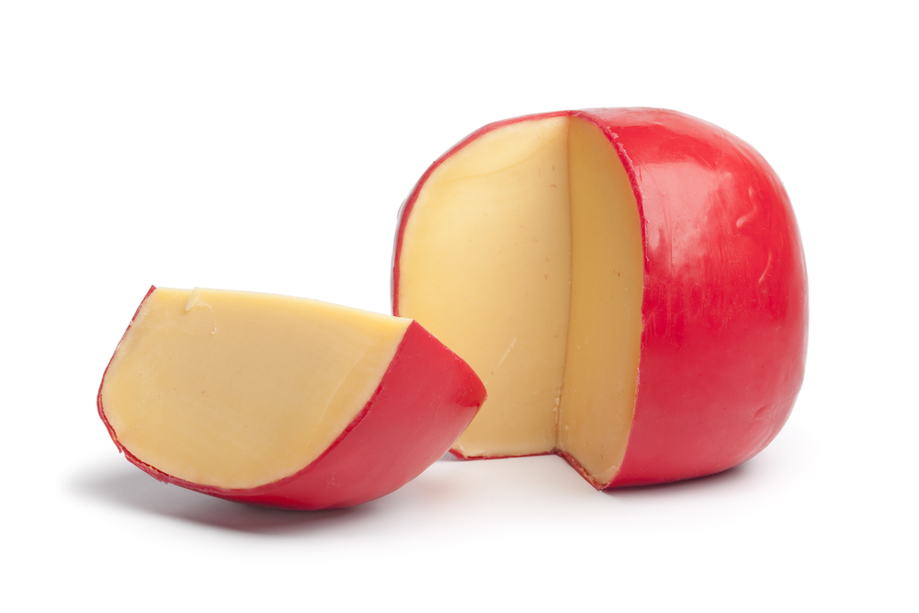

Dutch Style
- Edam
- Gouda.

Stretched Curd
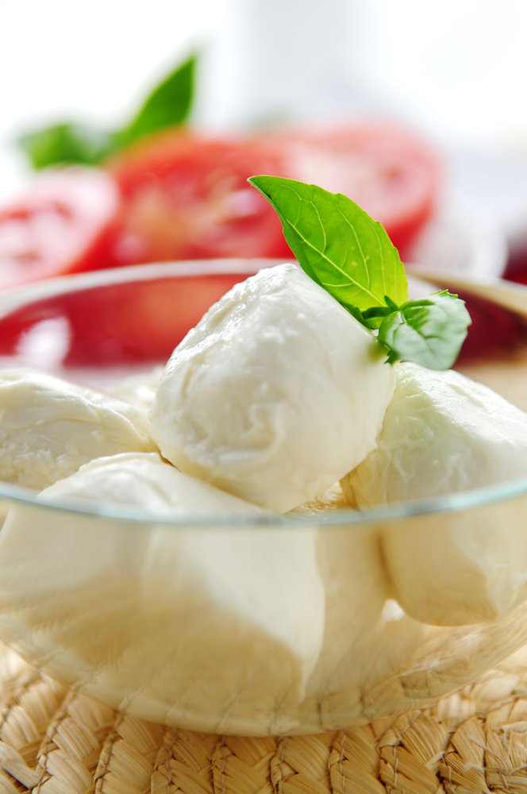
The curds are mixed with whey, heated, stretched or kneaded to obtain an elastic and slightly rubbery consistency.
The cheese is then formed into the desired shape and can be eaten fresh, dried or smoked:
- Mozzarella
- Bocconcini.

Washed Rind
Have strong smelling, sticky and often orange rind, produced by washing the rind with saline or alcohol during maturation.
Many styles can have washed rind:
- Tilsit
- Semi soft style rind.

Cheddar
The curd goes through several processes to give a distinctive piquant, nutty flavour.
These processes include, cutting and heating; milling and moulding of the curd:
- Cheddar is the Classic English Cheese
- Cheshire
- Red Leister
- Colby
- Glouster.

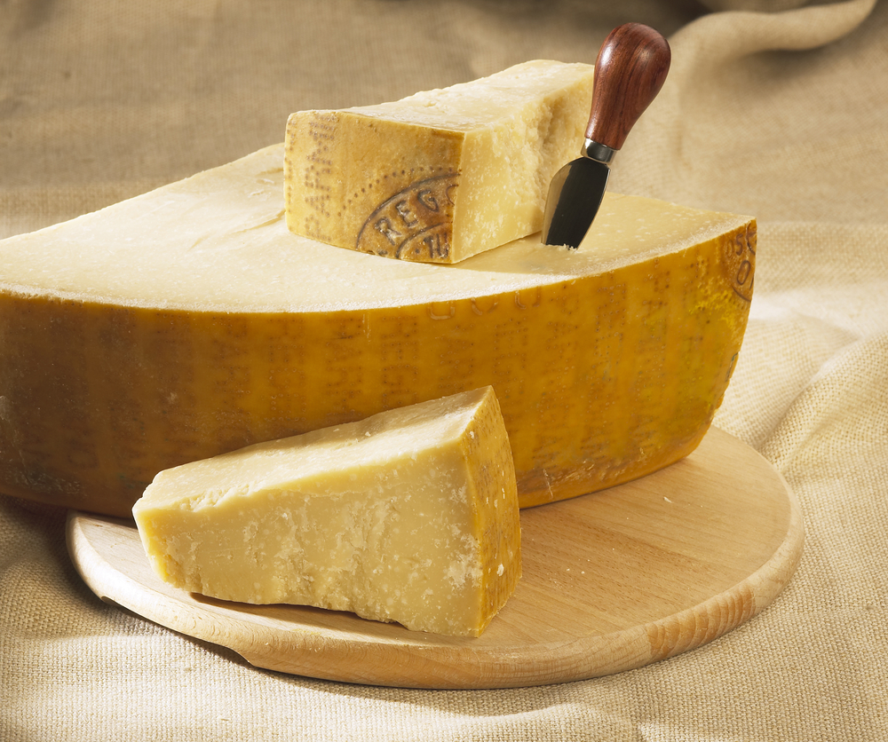
Hard
Hard cheeses have low moisture content due to aging and maturing. As the name suggests they are hard and have a long shelf life.
For example:
- Parmesan
- Pecorino
- Peparto
- Romano.

Cheeses from non European countries
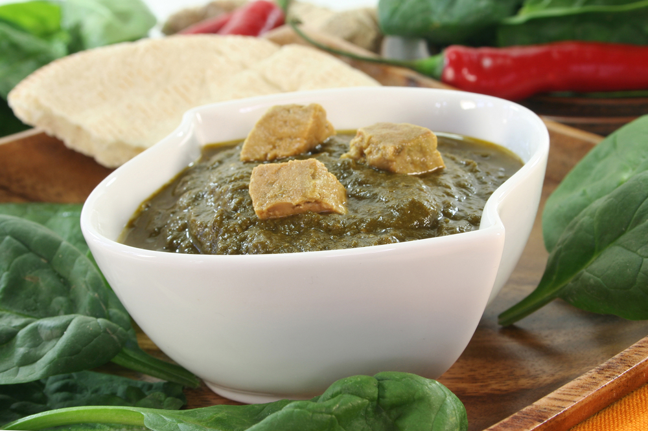
China
- Rushan Cheese – cows milk from Chinese province of Yunnan
- Rubing Cheese – goats milk cheese.
India
Paneer – an acid (lemon juice or vinegar) set cheese. Similar to cottage cheese.

Work Projects
It is a requirement of this Unit you complete Work Projects as advised by your Trainer.
You must submit documentation, suitable evidence or other relevant proof of completion of the project by the date agreed to with your Trainer.
Student needs to write a report. The report needs to include the following information.
Information regarding the following needs to be included in the report.
  - Compile a list of cheese suppliers in your area or city:
- Include the business details of each supplier
- Name of business, address
- Name of manager
- Contact details: phone, fax, email
- Business registration details
- Food Safety Plan details: is the business registered and allowed to operate as a supplier of food.
Need to have details of a list 3 suppliers or a number agreed by your trainer.
Students need to compile a report about each supplier regarding the suitability of said supplier to supply cheese:
- This list needs to include price and unit weight of each cheese available
- Does the supplier have cheese suitable to enterprise needs.
Maybe multiple suppliers need to be used by the enterprise to source all the product required.
1.2. Complete list of all cheeses varieties listed below.
Students need to give a brief overview of each cheese 30 words or less.
What are the characteristics of each cheese?
- Fresh
- White mould
- Blue mould
- Semi hard
- Stretched curd
- Washed rind
- Cheddar
- Hard.

Summary

Select supplier to purchase cheese and equipment
Select Supplier
A supplier needs to be able to suit the requirements of the enterprise:
What is the selection standard?
How often can product be sourced?
What is the pricing structure?
Identify Cheese varieties
There are many cheese varieties available. Enterprises need to decide what they wish to provide to the customer base. It is a mistake to only provide what is popular with the chef or Food and Beverage Manager.
What are the likes and dislike of the customers?
Enterprises need to be safe but should also push boundaries to try to introduce new product to the market at all times.

Element 2:
Prepare cheese for service

2.1 Bring product to appropriate serving temperature

Introduction
In a normal situation in Australian conditions cheese should only need half an hour to an hour to come to room temperature.

Cheese is served at room temperature allow the true flavours to be tasted in the mouth.
In warmer more humid climates this may need to be controlled:
- 18ºC – 22ºC
- Keep cheese covered to prevent drying on the surface
- Protect from outside contamination
- Do not crush or squash.
Fresh cheese that is being used as a dessert and has been sweetened and flavoured would not be served at room temperature.
The natural flavour characteristics that do come out when cheese is at room temperature have been compromised by the addition of sugar and flavouring:
- Ricotta
- Cottage cheese
- Neuchatel
- Marscapone.

2.2 Use correct preparation equipment safely

Utensils and equipment used to prepare cheese must be clean
Equipment
Cheese cutting wires:
- Structured like piano wire
- Thin multi layer plaited strands.
These are anchored to base plate, the cheese is placed on the base plate and the wire is drawn over the round and pulled through the cheese until it is cut all the way through.
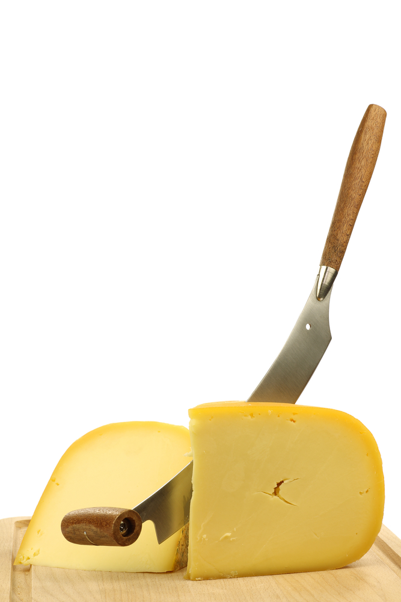
There are generally 2 styles of cutters
- Wire is attached to a large upside down U shape metal bar with the wire stretched between the two ends. A groove is in the base plate to allow the wire to pass through the base of the cheese.
- Free wire attached to a base and has a metal bar attached to the free end. This is used to grip the wire to enable it to be pulled through the cheese.
Wire is preferred as it has little surface that the cheese can grip.
Cheese has a tendency to grip the blade of the knife and it 'jams' making it hard to move through the cheese.
It is not good to heat the blade as it will melt the cheese and it just grips harder.
If using a knife to cut cheese, dip blade into cold water and shake off excess:
- Clean knife after every cut, EVERY CUT!!!!
Remember
Care must be taken when using wire because if fingers are under wire when final cut is made much damaged can be done. Fingers come off easily.
When using knife to cut cheese care must also be taken with fingers are flat on top of knife, not curled.

2.3 Prepare required garnishes and accompaniments to complement service style

Accompaniments to serve with cheese
Cheese can have a strong flavour and heavy mouth feel so this would be served with fresh fruit to clean the palate:
- Parmesan cheese is best served with fresh pear:
- Simple, elegant, sophisticated
- Cheddar cheese can be both strong and mild flavour:
- Serve with breads or dried fruits, fresh fruits.

Garnishes
Garnishes can be used to decorate the platter or plate.
Garnishes can be elaborate or simple. Each enterprise will have different expectations. No strict rules apply:
- Cut and peeled fruits will cleanse the palate and add sweetness
- Fresh vegetable can be added to plate
- Pickled vegetables can be added.
Some cheeses go well with beverages, either alcoholic or non alcoholic.

Sauces
Condensed fruit juices can make excellent accompaniments to be served with cheese:
- Wine can be reduced and sweetened then served
- The boiling makes the alcohol evaporate away and the flavour left is just from the fermentation of the base ingredient and added ingredients like sugars and spices.
Spices can be added to improve flavour:
- Example: Blue cheese drizzled with Balsamic Vinegar reduction.

Work Projects
It is a requirement of this Unit you complete Work Projects as advised by your Trainer.
You must submit documentation, suitable evidence or other relevant proof of completion of the project by the date agreed to with your Trainer.
Student needs to write a report. The report needs to include the following information.
Information regarding the following needs to be included in the report.
2.1 How the cheese is to be prepared for service:
- What precautions need to be in place so the cheese remains safe for consumption?
2.2. Compile a list of all equipment and consumables that could possibly be needed to serve the cheese:
- Service can be for single serve or buffet serve.
2.3. List the garnishes required and the preparation requirements:
- Give a variety in selection.
2.4. List accompaniments for service:
- The amount per person
- Be generous: cheese cost is more than accompaniments.

Summary

Prepare cheese for service
Cheese is best served at room temperature
Remove from chilled storage at least 1 hour before service
Keep protected from adverse conditions until required:
Keep away from work area
Keep safe from contamination
Equipment and utensils used for service need to be clean
Can be specialist equipment
Have an interesting selection of tasty accompaniments to compliment the cheese
Serve with plenty of bread and crackers:
Cheese is expensive
Bread and crackers are not expensive.

Element 3:
Present cheese

3.1 Present cheese to enterprise standards
Presentation of cheese varies with the level of service expectations.

Cheese can be very expensive, especially good quality
Allow a total of 80 – 90 g cheese per person or approximately 30 g of each cheese if you are serving a selection.
Remove cheese from refrigeration one hour before service:
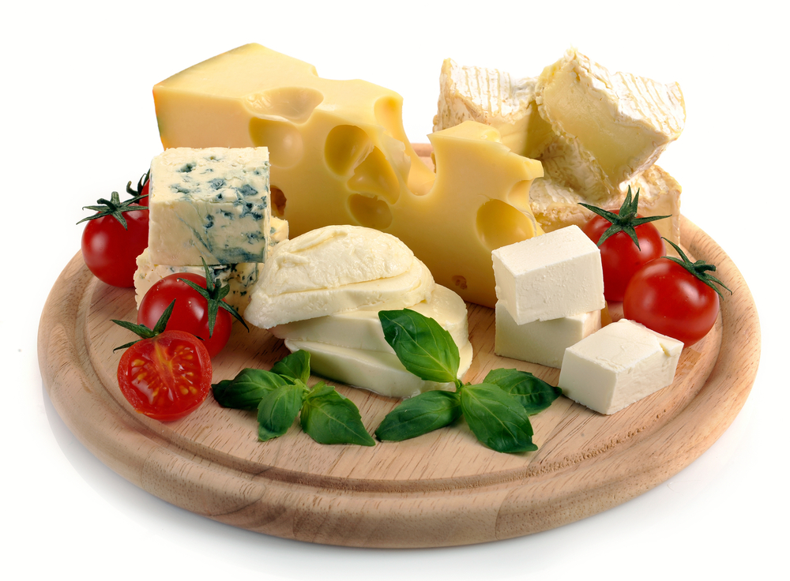
- Choose cheeses from different categories to offer a variety of textures, colours and flavours
- Enhance the presentation of a platter with different cheese shapes or by placing wedges at different angles on the plate
- Cheeses with rinds should be cut from the centre of the cheese to the edge, allowing each part of the cheese to be enjoyed
- When serving more than one cheese, always use a different knife for each cheese to prevent mixing flavours
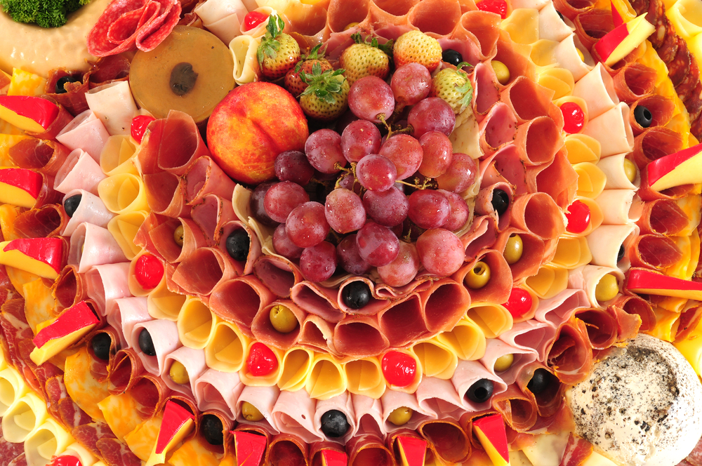
- Remove cheese from the refrigerator at least one hour before service then cut to size and plate for presentation. Serve cheeses at room temperature to achieve optimum flavour. To minimise wastage, only remove the portion of cheese that is required for use
- To avoid cheeses drying-out whilst bringing them to room temperature, cover with a clean, damp tea towel or individually cover with plastic wrap
- Serve with complementary accompaniments that don’t overpower, such as quince paste, muscatel clusters, figs, pears or crisp apples
- Keep it simple, yet stylish and feature only one or two accompaniments to complement the cheese selection on offer
- Encourage guests to cut cheese wedges along the length (from ‘nose to tail’) rather than cutting off the point!

3.2 Decorate cheese with complementary garnishes and accompaniments

Complementary

Complementary in flavour; this adds value to the eating sensation.

Dried fruits
Add sweetness and intensity of flavour.

Fresh fruits
These can help to break up strong cheese flavour by adding moisture to mouth and sweetness from fruit.

Sauces
Can be drizzled over cheese to add flavours.


Crackers
Provide the contrast of crisp crunch in the mouth with soft cheese.

Breads
Plain or fruit breads both work well with cheese. Sourdoughs can compliment cheese characteristics.

How much per serve?
- 1/4 fresh pear per person

- 6 almonds
- 3 slices of fruit bread
- 4 water crackers
- 3 dried apricots
- 70 g per cheese.
A platter will only be different in regard to portion sizes.

Work Projects
It is a requirement of this Unit you complete Work Projects as advised by your Trainer.
You must submit documentation, suitable evidence or other relevant proof of completion of the project by the date agreed to with your Trainer.
Student needs to write a report. The report needs to include the following information.
Information regarding the following needs to be included in the report.
3.1 Draw a plate diagram of how the cheese will be served:
- Cheese should be centre of plate
- Draw in place accompaniments and garnishes that will be used.

Summary

Present cheese
Present cheese
Cheese can be the finale to a satisfying meal. It can replace desserts
Service should be elegant and simple
Serve at room temperature
Should not be dry when served.
Decorate cheese with garnishes and accompaniments
Do not over complicate the presentation
Use a variety of accompaniments
A mixture of dried and fresh fruits can be used.

Element 4:
Store cheese

4.1 Minimise wastage through correct purchasing practices



Introduction
Purchase only what is required for the service requirements until the next supply period.
Do not carry cheese that is not going to be used.
This is easier to achieve in metropolitan and urban areas.
In rural areas supply can be more difficult and special consideration may need to be made.
When purchasing it is important to look at rate of usage. Do not buy 10 kg just to get the discount for bulk purchasing.
Buy only what can be used in the purchasing cycle.
The purchasing cycle is the time that is available before the opportunity to purchase comes again:
- Once a week
- Twice a week
- Once every 2 weeks.
When new stock is received make sure that old stock is used before new stock is accessed.
When preparing for service do not prepare more than what is perceived to be required or what is ordered.

4.2 Minimise wastage through correct storage practices

Correct Storage for cheese

Fresh Unripened cheeses
Cottage, Ricotta, Cream cheese, Feta and marscapone
Keep chilled for up to 2 weeks in container in which they were purchased. Must be stored at less than 4ºC.
Feta cheese if purchased in brine must be kept/stored on brine.
Freezing not recommended.


Stretched curd
Mozzarella, Bocconcini, Haloumi
Mozzarella and Bocconcini, keep chilled in water for up to 1 week if fresh.
Cooked varieties can keep in coolroom for up to 4 weeks.
Haloumi keep well covered in brine or in plastic wrapping vacuum packed.

White mould cheeses
Brie, Camembert
Keep in original wrapping until ripened (soft in centre) up to 4 weeks, maybe more.

Do not store near strong flavoured cheeses as the aroma could be absorbed.
Freezing no recommended.

Washed Rind Cheese
Store chilled in original wrapper for up to 4 weeks.
As it ages the smell will change. Strong ammonia smell means cheese is too old.
Freezing not recommended.


Cheddar style cheese
- Store chilled
- Will come in cloth or waxed:
- Black wax 18 months
- Red wax 12 months
- Will keep for several months if not cut
- When cut any unused cheese will need to be wrapped to prevent drying
- Freezing not recommended.

Eye cheese
Store chilled in coolroom wrapped in plastic wrap for several weeks. Avoid air contact as this will cause surface to dry and crack.
If this happens then cheese can be used in cooking.
Freezing no recommended.


Blue Cheeses
Store chilled in original wrapper for up to 4 weeks. When cut only store for 2 weeks with foil against cut surface.
Blue cheese can be very strong in aroma so care must be exercised when storing in coolroom. Store away from.
Freezing no recommended.

Hard Cheese

Can be stored for long periods of time due to low moisture content. If stored properly it can last for 12 months:
- Freezing is not recommended
- Can be frozen if grated.

General notes on Storing cheese
Correct storage is a vital factor in nurturing cheese to its optimum serving condition:
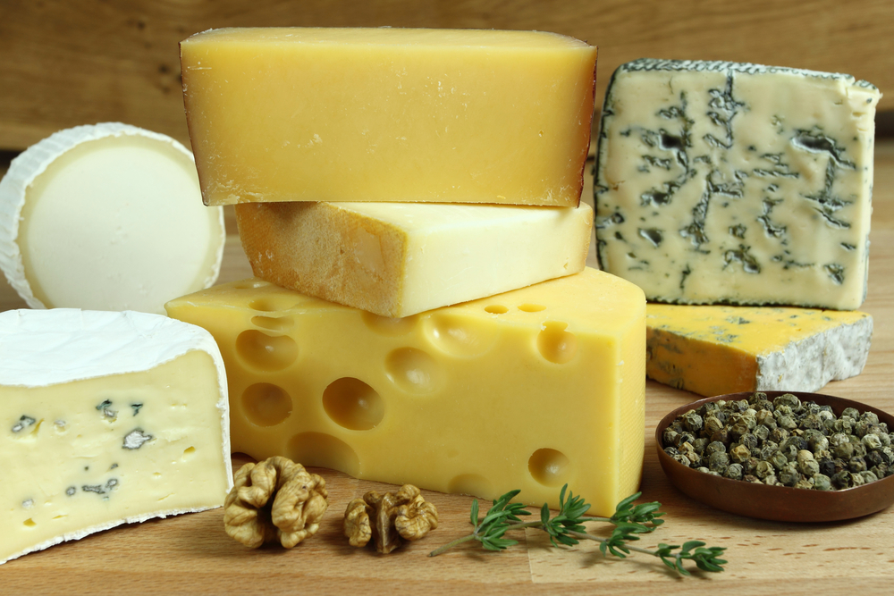
- As a general rule and where possible, always store cheese wrapped in its original wrapper
- Use waxed paper (or loose cling wrap, depending on the cheese style) if the original wrapper is not available as it allows the cheese to breathe
- Avoid using foil for wrapping blue cheese for more than 2 weeks as it will react with the cheese
- Store fresh unripened cheeses in a covered container or tub and use preferably within a week of purchase or as indicated by the use-by date
- As a general rule, the harder the cheese the longer its shelf life. Factors that will affect shelf life are: the age of the cheese when purchased, and how it is cared for after purchase. Refer to the individual cheese classifications for further information
- Store blue mould and washed rind cheeses separate to other foods
- Cheeses should be stored in the refrigerator at temperatures between approximately 4ºC – 6ºC
- Only cover the cut surface of cheese to enable the natural rind to breathe, except for earthy smelling washed rinds and blue cheeses that require individual wrapping and storing to reduce odours in the refrigerator
- When cheeses are removed from their original packaging, avoid stacking them on top of one another as it damages the rind, misshapes the cheeses and hinders further maturation.

4.3 Apply appropriate hygiene standards in the storage and handling of cheese

Good Hygiene Standards apply when handling all foods. Handling cheese is the same.
Check local authorities' requirements.
Read Australian Standards below which are defined by the World Health Organisation and HACCP standards.

Hygiene Standards
Hygiene of food handlers
(1) A food handler must, when engaging in any food handling operation

(a) Take all practicable measures to ensure his or her body, anything from his or her body, and anything he or she is wearing does not contaminate food or surfaces likely to come into contact with food
(b) Take all practicable measures to prevent unnecessary contact with ready-to-eat food
(c) Ensure outer clothing is of a level of cleanliness that is appropriate for the handling of food that is being conducted
(d) Only use on exposed parts of his or her body bandages and dressings that are completely covered with a waterproofed covering
(e) Not eat over unprotected food or surfaces likely to come into contact with food

(f) Not sneeze, blow or cough over unprotected food or surfaces likely to come into contact with food
(g) Not spit, smoke or use tobacco or similar preparations in areas in which food is handled and
(h) Not urinate or defecate except in a toilet

(2) A food handler must wash his or her hands in accordance with subclause

(a) Whenever his or her hands are likely to be a source of contamination of food
(b) Immediately before working with ready-to-eat food after handling raw food and
(c) Immediately after using the toilet
(3) A food handler must, when engaging in a food handling operation that involves unprotected food or surfaces likely to come into contact with food, wash his or her hands
(a) Before commencing or re-commencing handling food
(b) Immediately after smoking, coughing, sneezing, using a handkerchief or disposable tissue, eating, drinking or using tobacco or similar substances and
(c) After touching his or her hair, scalp or a body opening
(4) A food handler must, whenever washing his or her hands
(a) Use the hand washing facilities provided
(b) Thoroughly clean his or her hands using soap or other effective means, and warm running water and
(c) Thoroughly dry his or her hands on a single use towel or in another way that is not likely to transfer pathogenic micro-organisms to the hands
- Every time the cheese is cut a fresh piece of plastic wrap should be used to seal cheese from outside contamination
- Every time cheese is handled, handlers should have 'clean' hands
- Every time cheese is cut, utensils should be clean
- Every time cheese can be contaminated if care is not taken.
If you cannot be clean!!!!!!
Wear food handling gloves and change them after handling every cheese.

4.4 Access and use cheese leftovers appropriately

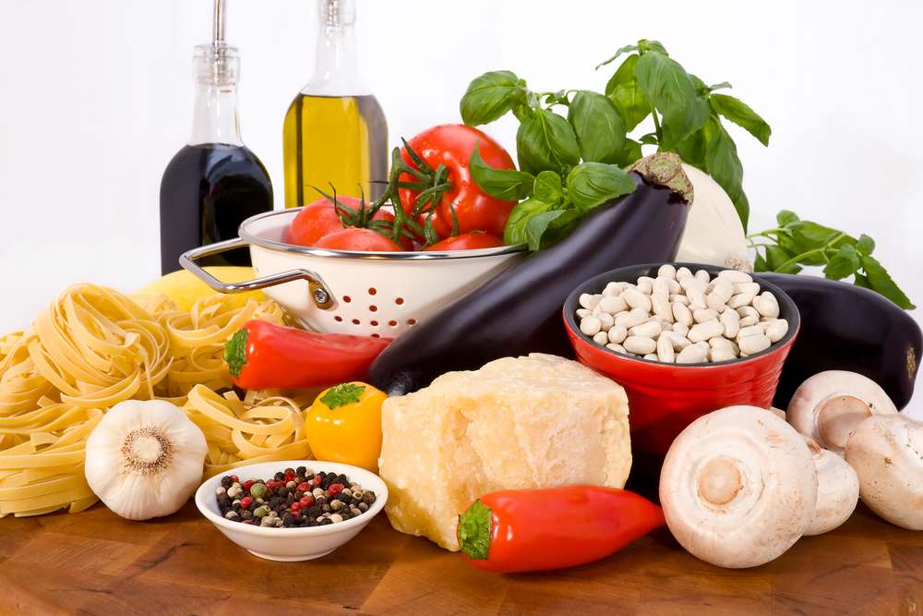
Cheese in Cookery
Cheese can be used in cookery as a basic ingredient or to add flavour, and can be used raw or cooked.
Several cooking methods can be used when preparing cheese.
It is often baked when mixed with other ingredients, very commonly grilled and shallow or deep fried.
It is found in many cold dishes such as sweets, salads, canapés, savouries and sandwiches.
Cheese can be used as an ingredient in soups, dips and spreads, as an accompaniment or a garnish.
It’s many different colours, textures and flavours make it a versatile product which can be made into many exciting dishes:
- Blue cheeses are often dropped into cream sauces to be used in pasta dishes
- Cream cheeses, cottage and ricotta styles are used in baked cheesecakes and desserts
- Marscapone cream cheeses as tira mi su, Italian coffee trifle dessert.
No cheese should be wasted. The only cheese that must go into the rubbish bin is cheese that has been dropped and flaaen on the floor.


Work Projects
It is a requirement of this Unit you complete Work Projects as advised by your Trainer.
You must submit documentation, suitable evidence or other relevant proof of completion of the project by the date agreed to with your Trainer.
Student needs to write a report. The report needs to include the following information.
Information regarding the following needs to be included in the report.
4.1 What is the required amount of cheese that will be purchased for 100 people?
- Allow for 3 styles of cheese.
4.2. Define how the cheese will be stored after being purchased:
- Look at the characteristics of each cheese selected.
4.3. Set the standards of hygiene expected by the enterprise with the handling of cheese:
- Validate your answer.
4.4. Describe how leftover cheese will be utilised in the kitchen. Cheese has been served for 100 people. What can be done with the left over cheese?
- Validate your answers in full. Explain how this can be achieved and why?

Summary

Store cheese
Minimise wastage through correct purchasing
Cheese can have a short or extended life
Knowledge of each variety or style need to be applied to maximise profitable returns when handling cheese
Purchase only what is required within the purchasing cycle.
Minimise wastage through correct storage
Store cheese in a protected environment. Away from strong odours
Wrap tightly to ensure moisture retention
When portion is cut from 'block' cheese ensure new wrapping material is used to re-wrap remaining portion of 'block' cheese.
Apply appropriate hygiene standards
Good hygiene practices need to be in place or loss of profit will happen very quickly
Clean utensils used to cut cheese
Personal hygiene is to be applied
Wash hands after handling each cheese.
Access and use cheese leftovers
Any leftovers can be utilised in menu items
Leftover is defined as small pieces that remain in kitchen storage area
Any cheese that goes out into restaurant does not go back into kitchen storage. Control has been lost and possibility of contamination has increased. Discard any cheese where control has been lost.

Presentation of written work

1. Introduction
It is important for students to present carefully prepared written work. Written presentation in industry must be professional in appearance and accurate in content. If students develop good writing skills whilst studying, they are able to easily transfer those skills to the workplace.

2. Style

Students should write in a style that is simple and concise. Short sentences and paragraphs are easier to read and understand. It helps to write a plan and at least one draft of the written work so that the final product will be well organized. The points presented will then follow a logical sequence and be relevant. Students should frequently refer to the question asked, to keep ‘on track’. Teachers recognize and are critical of work that does not answer the question, or is ‘padded’ with irrelevant material. In summary, remember to:
- Plan ahead
- Be clear and concise
- Answer the question
- Proofread the final draft.

3. Presenting Written Work
Types of written work
Students may be asked to write:
- Short and long reports
- Essays
- Records of interviews
- Questionnaires
- Business letters
- Resumes.
Format
All written work should be presented on A4 paper, single-sided with a left-hand margin. If work is word-processed, one-and-a-half or double spacing should be used. Handwritten work must be legible and should also be well spaced to allow for ease of reading. New paragraphs should not be indented but should be separated by a space. Pages must be numbered. If headings are also to be numbered, students should use a logical and sequential system of numbering.
Cover Sheet
All written work should be submitted with a cover sheet stapled to the front that contains:
- The student’s name and student number
- The name of the class/unit
- The due date of the work
- The title of the work
- The teacher’s name
- A signed declaration that the work does not involve plagiarism.
Keeping a Copy
Students must keep a copy of the written work in case it is lost. This rarely happens but it can be disastrous if a copy has not been kept.
Inclusive language
This means language that includes every section of the population. For instance, if a student were to write ‘A nurse is responsible for the patients in her care at all times’ it would be implying that all nurses are female and would be excluding male nurses.
Examples of appropriate language are shown on the right:
Mankind | Humankind
Barman/maid | Bar attendant
Host/hostess | Host
Waiter/waitress | Waiter or waiting staff

Recommended reading
Brown, Bob; 2013; The Complete Book of Cheese; CreateSpace Independent Publishing Platform
Buffardi, Michelle; 2013; Great Balls of Cheese; Houghton Mifflin Harcourt
Culture Magazine; 2012; Cheese For Dummies; For Dummies
DK Publishing 2009; The World Cheese Book; DK Publishing
Fletcher, Janet; 2000; The Cheese Course; Chronicle Books
McCalman, Max; 2002; The Cheese Plate; Clarkson Potter
McCalman, Max; 2005; Cheese: A Connoisseur's Guide to the World's Best; Clarkson Potter
Studd, Will; 2009; Chalk and Cheese; Purple Egg

Trainee evaluation sheet

Select prepare and serve various cheeses
The following statements are about the competency you have just completed.
Please tick the appropriate box | Agree | Don’t Know | Do Not Agree | Does Not Apply
There was too much in this competency to cover without rushing.
Most of the competency seemed relevant to me.
The competency was at the right level for me.
I got enough help from my trainer.
The amount of activities was sufficient.
The competency allowed me to use my own initiative.
My training was well-organized.
My trainer had time to answer my questions.
I understood how I was going to be assessed.
I was given enough time to practice.
My trainer feedback was useful.
Enough equipment was available and it worked well.
The activities were too hard for me.

The best things about this unit were:

The worst things about this unit were:

The things you should change in this unit are:

Trainee Self-Assessment Checklist
As an indicator to your Trainer/Assessor of your readiness for assessment in this unit please complete the following and hand to your Trainer/Assessor.

Select prepare and serve various cheeses
 |  | Yes | No*
Element 1: Select supplier to purchase cheese and equipment
1.1 | Identify and select suppliers for purchasing of products
1.2 | Identify cheese varieties required by the enterprise
Element 2: Prepare cheese for service
2.1 | Bring product to appropriate serving temperature
2.2 | Use correct preparation equipment safely
2.3 | Prepare required garnishes and accompaniments to complement service style
Element 3: Present cheese
3.1 | Present cheese to enterprise standards
3.2 | Decorate cheese with complementary garnishes and accompaniments
Element 4: Store cheese
4.1 | Minimise wastage through correct purchasing practices
4.2 | Minimise wastage through correct storage practices
4.3 | Apply appropriate hygiene standards in the storage and handling of cheese
4.4 | Access and use cheese leftovers appropriately

Statement by Trainee:
I believe I am ready to be assessed on the following as indicated above:
Signed: | _____________________________ | Date: | ______ / ______ / ______
Note:
For all boxes where a No* is ticked, please provide details of the extra steps or work you need to do to become ready for assessment.





